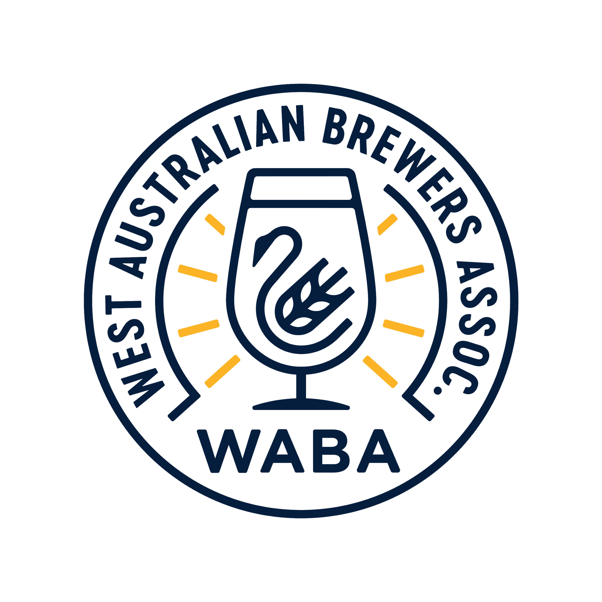
Western Australian Brewers Association

2020 Annual General Meeting Agenda:

Friday, July 17th 2020
4.00pm – 4.30pm meeting start

Ellerslie Hop -WA
Unit 2/ 32 Horus Bend
Bibra Lake, WA 6163
Andy welcoming – 4.30pm. People joining via zoom. Thanks to Ellerslie for hosting.
- Welcome, apologies and attendance
Andrew Scade (President/ Bevy)
Brendan Day (V.P. Cheeky Monkey)
Robbe Bryce (Secretary/ Thorny Devil)
Claire Donovan (E.O./ Konvoy)
Dirk Penny (Gage Roads)
Leon Marais (Impi)
Jan Bruckner (Last Drop)
Alan Proctor (Billabong)
Ken Arrowsmith (Beerland)
Steven Blaine (100 Proof/ Liquid Mix)
Ashley Allen (Cheeky Monkey)
Margaret McCarron (Colonial Brewing)
Chris Poulton (Summer Creek)
John Stallwood (Nail)
Jarrod Fuller (Zendoke)
Eamonn Barns (South Freo Brewing)
Bronte O’Donoghue (Feral)
Laura Williams (Mult-Colour)
Roger Bussell (Retired)
Rhys Lopez (Otherside)
Marcus Visic (Perth Royal Beer Awards)
Kellie Clements (Perth Royal Beer Awards)
Adam Watts (Outback Brewing)
Patrick Matan (Ellerslie Hops)
Peter McCappion (Thorny Devil Brewing)
Brody Watts (Seasonal Brewing)
Matt Jessop (Little Creatures)
Sean (Erosion Meadery)
Adrian Godwin (Little Tap Trailor)
Tim (Golden West)
Mark and Trina Rivers (Three Rivers)
Brian and Julia Fitzgerald (Artisan)
George Vander Mealen (Indiv. Member)
Fabian Jenkins (Bintani)
Sean Symons (White Lakes Brewing)
Ross Lewis (Dingo Brewing)
Lukas (Maven Coolers)
- F20 Reports (President and Treasurer)
President: We chose to cancel beer week, coming back next year as well as conference. PRBA coming, AIBA September. CDS Coming October 2020.

Treasury: $14,554 bank balance. Relatively neutral spending/ earning but less than what was expected due to Covid.

- Election of Committee Office Bearers – President, Vice- President, Treasurer and Secretary
No nominations.
Yes to all current committee staying on for another year.

- F21 strategy
Review of vision and missions: WABA’s vision is to put WA Beer on the map. Whether that’s hyperlocal, interstate or internationally, WABA’s works to raise the profile, technical ability and public awareness of WA Beer for its members and the State.
WABA’s mission is to support, protect and promote the growth of all WABA members and WA Beer.

4.1 Support (education sessions, F21 Brewers Conference)
Conference: Only done one so far but want to do another. Missed this year due to covid. 2021 hoping for 200 people and 30 breweries in attendance. Want to keep it affordable at $75pp. Sponsorship has helped with costs and helped keep it cost neutral. Cost about $10k

Education sessions:
HPA – Hop harvest with Brad.
Claire – Export workshop with Freo Chamber of Commerce.

Quarterly meetings: July, October, March, South West in August

Regional Support: Need a regional support person, better access through virtual connections like Zoom.

4.2 Protect (Container deposit scheme update, stolen kegs)

Protect – see presentation notes

CDS: Coming in October. We’re more than happy to help breweries with WARRRL info and trying to relay information as it comes to us.

Stolen kegs policy. We started doing some awareness around this last year but we’d like to pick it back up and push it. The steps are; 1. awareness for the public. & 2. Need to know how to interact with police, gumtree & marketplace etc.

4.3 Promote (WA Beer Week, PRBA, Freo Beer Fest and Drink West, Drink Best cartons and branding and new logo).

WA Beer Week: 20th year in June 2021. Chris is back with Tim assisting. Challenge is to make it as big as 2018 November beer week.
We know we need to grow the market. For 2020, Chris and Tim were working on the perfect pair combining breweries and pubs.

Looking to line up with PRBA and continue alignment between two organisations.

Freo Beer Fest: Looking to grow relationship. WABA will be taking over the Masterclass program in 2020. Opportunity to talk to punters re stolen kegs. Dropping the beer stall. Continue with Air liquide sponsorship. Create a staff chill out area for members.

Drink West Drink West Campaign.
New assets and logos done for WABA celebrating ‘Drink West, Drink Best’. BWS Cartons Kicking of the first phase of the campaign. Due out 12 August.
Impi – wondering why they didn’t get in, can they get in? Will discuss with them after meeting.
Blainey – Can we get into independent bottle shops? Andy – Yes, just doing BWS first to iron out bugs, etc. This first carton is exclusive to BWS.
Campaign assets will be released shortly. They are for all members to use and to celebrate being West Australian . Campaign will grow over time.

Overarching Actions:
Maintain executive Role – Claire leaving down the track. Have a new person planned to take over from her.
Find regional support/coordinator
Deliver tangible value to waba members!
Determine what WABA is going to look like in the future. Guy has given us a proposal for long term strategy for consideration.

- F21 fee update and proposed budget breakdown
Membership discount 25% this year.

- General Business
Seven West want to do another beer magazine. With WABA’s involvement in 2016 the magazine was a great success and they want WABA to champion the magazine again with members. Specifically to get members to list in the brewery directory for $350. The magazine will also spruik the PRBA winners. Due out in October.

A.P. (Billabong) - How many financial members? How many breweries?
A.S. (President) – About 20 financial members. 77 breweries we’re in contact with. About 25 new ones. Over 100 now in WA.
Freo Beer Fest
A.P. - We need to improve and get more members. Used to be linked with Freo Beer Fest.
Why has it changed? - A.P. & J.S. (Nail)
A.S. - Moved to tiered structure several years ago.

A.W. (Outback Brewing) - Why is Freo beer fest have cocktails and wine? Should be beer focused. Andy – It’s Stacy’s thing. It is WA focused, no other festival like it in Australia. We have paid members that are distilleries and cideries.
Member: Would like discount locked in for Freo beer fest. A.S. We were too late this year but it’s something we can raise for next year.
P.P. (Nowhereman via zoom) - Cocktails etc, bring more people to the event (in response to A.W.)

WA Beer Week

B.W. (Seasonal) - wants WA Beer Week to be more inclusive, not just appeal to the beer lovers. How can we do that?
S.B. (100 Proof) – wa beer week always attracts same old people. Need to talk to more people by getting into run of the mill venues.
B.D (V.P.): WA Beer Week perfect pair, i.e. pint parmy is about broadening the WA Beers.
S.B.- Large venues, north or the river not pouring wa beers for wa beer week. S.B. offering LMX to get into more venues for WA Beer week.

A.S.- wanting to get into non craft beer venues and continue to grow.

R.L (Otherside)- could get AHA involved to do an event with a local brewery.

B.D. – last year the committee made a WA Beer week charter with the help of Guy Southern.

M.M (Colonial) – breweries are spread too thin. Needs to be more venue driven. Breweries can do their own thing. Snobs and geeks go to all the fancy events. We need to drag in normal punters.

Independent Brewers Association

P.P. Do Waba and IBA have an open dialog? Is WABA doing anything for Indie Day?

A.S. Jamie cook came over a while back. Haven’t spoke for a while, open to chatting. Indi beer – waba not doing much. We’ll post on social. Up to our members what we participate in.

Meeting closed 5:20pm

